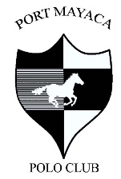
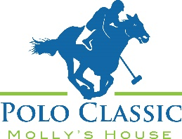
Molly’s House Polo Classic
March 4, 2023
Port Mayaca Polo Club, Okeechobee
12:00-4:00pm Rain or Shine

Sponsor Commitment Form

Please complete this form, scan, and email to Aducote@mollyshouse.org or mail to

Molly’s House 430 SE Osceola St., Stuart, FL 34994

Requested Sponsor Levels

- Premier Sponsor ($15,000)
- Team Sponsor ($7,500) SOLD OUT
- Best Pony Sponsor ($5,000) SOLD OUT
- Champagne Sponsor ($5,000) SOLD OUT
- Best Hat Sponsor ($3,000)SOLD OUT
- MVP Sponsor ($3,000)
- Classic Car Show Sponsor ($3,000) SOLD OUT

- Dressage Sponsor ($3,000)
- VIP Sponsor ($2,500)
- Chalet Sponsor ($2,500)
- Tailgate Sponsor ($2,500)
- Golf Cart Sponsor ($1,000)
- Mallet Sponsor ($500)

- I am unable to sponsor this year but would love to offer a donation to the cause $_______
- Check Enclosed – Preferred Method Make checks payable to Molly’s House (address a bottom)
- Please charge my credit card: 3 methods to choose from
  - Name______________________ Card #_______________________ Exp______ CVS______
  - Or visit our website www.mollyshouse.org/Events/2023 Polo Classic and complete your transaction online
  - Or call us to run your card 772-223-6659.

Total Sponsorship / Donation $_________

Name on Card _________________________________________________ Phone:____________________

Address for Card__________________________________________________________________________

Email______________________________________ Signature_____________________________________

Please email logos & ads to aducote@mollyshouse.org February 15, 2023 is the final day to submit. If you miss the deadline, we will only display your name/company name.

Molly’s House is a 501(c)3, non-profit organization as recognized by the Internal Revenue Service. "A COPY OF THE OFFICIAL REGISTRATION AND FINANCIAL INFORMATION MAY BE OBTAINED FROM THE DIVISION OF CONSUMER SERVICES BY CALLING TOLL-FREE (800-435-7352) WITHIN THE STATE. REGISTRATION DOES NOT IMPLY ENDORSEMENT, APPROVAL, OR RECOMMENDATION BY THE STATE."
REGISTRATION NUMBER CH7433.

