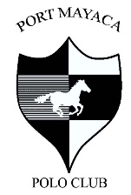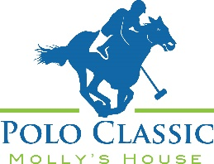

**Molly’s House Polo Classic**

**March 4, 2023**

**Port Mayaca Polo Club, Okeechobee**

**12:00-4:00pm Rain or Shine**

Sponsor Commitment Form

Please complete this form, scan, and email to [Aducote@mollyshouse.org](mailto:Aducote@mollyshouse.org) or mail to

**Molly’s House 430 SE Osceola St., Stuart, FL 34994**

Requested Sponsor Levels

* Primer Sponsor ($15,000)
* Team Sponsor ($7,500) **SOLD OUT**
* Best Pony Sponsor ($5,000) **SOLD OUT**
* Champagne Sponsor ($5,000) **SOLD OUT**
* Best Hat Sponsor ($3,000) **SOLD OUT**
* MVP Sponsor ($3,000)
* Classic Car Show Sponsor ($3,000) **SOLD OUT**
* Dressage Sponsor ($3,000)
* VIP Sponsor ($2,500) 2 Remaining
* Chalet Sponsor ($2,500)
* Tailgate Sponsor ($2,500)
* Golf Cart Sponsor ($1,000)
* Mallet Sponsor ($500)
* I am unable to sponsor this year but would love to offer a donation to the cause $_______
* Check Enclosed – **Preferred Method** Make checks payable to Molly’s House (address a bottom)
* Please charge my credit card: 3 methods to choose from
  + Name______________________ Card #_______________________ Exp______ CVS______
  + Or visit our website [www.mollyshouse.or](http://www.mollyshouse.or)g/Events/2023 Polo Classic and complete your transaction online
  + **Or call us** to run your card 772-223-6659.

Total Sponsorship / Donation $_________

Name on Card _________________________________________________ Phone:____________________

Address for Card__________________________________________________________________________

Email______________________________________ Signature_____________________________________

Please email logos & ads to [aducote@mollyshouse.org](mailto:aducote@mollyshouse.org) February 15, 2023 is the final day to submit. If you miss the deadline, we will only display your name/company name.

Molly’s House is a 501(c)3, non-profit organization as recognized by the Internal Revenue Service. "A COPY OF THE OFFICIAL REGISTRATION AND FINANCIAL INFORMATION MAY BE OBTAINED FROM THE DIVISION OF CONSUMER SERVICES BY CALLING TOLL-FREE (800-435-7352) WITHIN THE STATE. REGISTRATION DOES NOT IMPLY ENDORSEMENT, APPROVAL, OR RECOMMENDATION BY THE STATE."

REGISTRATION NUMBER CH7433.