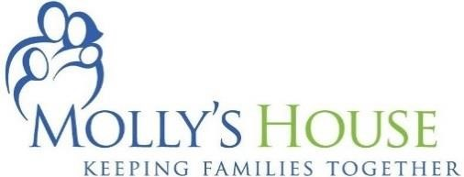

Since 1996, Molly’s House has provided an affordable oasis for families facing a medical crisis. Whether it is a loved one in an emergency room, a child in the neonatal unit, patients with cancer or in Hospice, Molly’s House offers a refuge.

Molly’s House can provide for these families in their time of need entirely due to the incredible support of our community. Please consider assisting Molly’s House with some of the items below. Get creative…you can start a campaign to put together needed supplies, raise money or take on a larger job as a service project with your club, family, friends or coworkers.

Gift Cards
• Publix |  | • Target | • Walmart
• Restaurants |  | • Walgreens | • CVS
• Local Attractions |  | • Home Depot | • Office Depot

General Supplies

- Aluminum Foil • Garbage Bags (13 gal) • Comet Cleaner
- Copy Paper • Cascade Gel Packs • Toilet Cleaner
- Paper Towels • Postage Stamps • Toilet Paper
- Plastic Containers w/ Lids • Glass Cleaner • Swiffer Wet or Dry
- Glass Stove Top Cleaner • Zip Lock Bags (all sizes) • White Wash Cloths
• New White Sheets King, Queen, Full & Twin • New White Pillowcases Standard
- New Blankets all sizes • Clorox Bathroom Spray
- Mattress Covers (water and dust mite proof) all sizes Hotel Luggage Cart
- Commercial grade door mats for 3 access doors Commercial Dolly
- Canned Goods – including hearty soups & stews

Projects & Large Items
- ADA Access for Serenity Garden $ 5,000
- Bathroom Re-Tiling (12 bathrooms @ $1000 ea.) $ 12,000
- Fence to enclose side of property $4800
- Privacy Fence – West side of property $1900
- Wireless Network Upgrades for working guests $4000
- ADA Accessibility Upgrades to Property $2500 - $5000

430 SE Osceola Street, Stuart, FL 34994
Ph: 772.223.6659 | Fax: 772.223.9990 | MollysHouse.org

